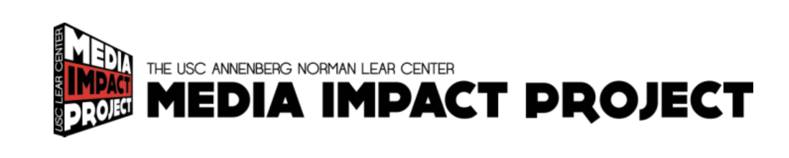
For Immediate Release (Distributed February, 2019):

Exploring Journalism’s Effects
Norman Lear Center researchers partnered with PBS FRONTLINE, HuffPost and The Guardian to understand the complex dynamics of media impact
Los Angeles, CA: What makes a news story impactful? A series of research conducted by the Norman Lear Center at the USC Annenberg School for Communication and Journalism were designed to help find out. The findings, which were released this week, can be used by journalists, digital media designers, and nonprofit organizations looking to create social impact through journalism. The research was conducted by the Lear Center’s Media Impact Project (MIP) and was supported by the Bill & Melinda Gates Foundation. Projects included:
What is social return on immersive media?
Many organizations are expending time and talent on immersive media formats, such as virtual reality, to tell their stories. Led by MIP Senior Fellow (and former Research Director) Beth Karlin, MIP researchers designed two studies to investigate if the impacts of immersive media were worth the additional production costs. They asked: Are viewers impacted differently if they view the same content with room-scale VR, Google Cardboard, or 360 video on a laptop? They found that more immersive VR platforms were the most effective at creating an enjoyable experience and engaging the sense of “being there,” but this presence did not necessarily lead to attitude or behavior change. In fact, the novelty of the medium created incentives to explore the space rather than absorb information, providing enormous potential for distraction from complex narratives or information-dense sequences. Balancing these characteristics is the key to developing journalistic content for this medium. Media partners: HuffPost, PBS FRONTLINE & Emblematic Studios. Read the HuffPost report. Read the FRONTLINE report.
Key Findings
- Participants enjoyed the immersive VR experiences more and felt more transported, both narratively and spatially.
- VR can be a less powerful tool for conveying facts than more familiar platforms, such as a laptop: users were more likely to accurately recall information from stories after using the laptop than the more immersive VR platforms.
- Participants using room-scale VR or immersive 360 video were more likely to look for more information about the subject after the experience.
- Viewing a 360 video through a cell phone made little difference compared to a laptop.
- None of the devices produced a distinguishable difference in participants’ intention to donate money, volunteer time or sign petitions.

What makes online calls to action most effective?
A recent development in online journalism has been the addition of “Call to Action” buttons to some articles about social and environmental issues. The goal of this study was to investigate the impact of these buttons on audience engagement and behavior. Data was collected from 54 articles on homelessness that ran in The Guardian’s “Outside in America” series. Each article included a Call to Action Button urging viewers to donate time and/or money to relevant causes. Led by MIP Senior Fellow (and former Research Director) Beth Karlin, researchers investigated whether using different types of action buttons, with different messaging and placement, resulted in different outcomes. Media Partners: The Guardian, Speakable. Read the full report.
Key Findings
- Action buttons placed at the bottom of an article had a higher click rate than buttons placed in the middle of the article.
- Buttons with multiple actions resulted in a higher click rate than buttons featuring only one action.
- The presence of a donation scale resulted in a lower click rate than when a donation scale was absent.
- Action buttons featuring city-level organizations had higher click rates than those featuring state or national organizations.
- Messages using moral norms — what someone ought to do — led to greater audience engagement than those employing social norms — what others are currently doing.
- Concrete messages led to greater audience engagement than abstract messages.
Designing online messages for impact: Tipsheet series
Based on the results of the studies above in conjunction with a comprehensive literature review of related behavioral science work, the Media Impact Project created a resource to help content creators optimize stories for impact with the help of social science. Nine tipsheets each introduce a research concept and the theory behind it, then provide specific tips on how website creators, journalists and nonprofits can employ the tips to generate better outcomes. Topics include the “Benefits of Concrete Language,” “The Power of Loss vs Gain Framing,” and “Using Social Norms.” Read the tipsheets.
“While there is no silver bullet to making impactful media, over forty years of research in the social and behavioral sciences points to a wide body of strategies, or ‘nudges,’ that can be leveraged to optimize messages for impact,” says Beth Karlin of See Change Institute and MIP Senior Fellow, who led the project. “We realized that most of this work had yet to be translated in one place for media practitioners and many are unaware of these insights and how they can be applied in online and broadcast media.”
Database for mixed methods media research
MIP researchers sought to contribute to the field a tool for researchers to better parse datasets used to measure media impact. Led by MIP Senior Fellow Heidi Boisvert, researchers looked to enhance the analytical process for media impact studies by building new open source database software (in collaboration with Natalia Rodriguez) that helps researchers map correlations across story coding datasets, Google analytics and survey data. The MIP Database was pilot-tested on a forthcoming study of the Guardian’s Global Development news coverage.
Please contact us if you would like to learn more about the Norman Lear Center Media Impact Project or our slate of projects exploring the impact of media on the world.
Contact: Laurie Trotta Valenti 323.557.1088

